Unit 7 Study Guide: Meiosis, Mutations, and Genetics
Lesson 14.1 Karyotypes Study Guide (Read ch. 14.1; pgs. 398-399)
Key Question: How are Karyotypes used?
1. What are scientists studying when exploring the human genome?
The full set of genetic information that an organism carries in its DNA

2. How do cell biologists make a karyotype?
They photograph cells in mitosis. Then arrange them in HOMOLOGOUS PAIRS in order of decreasing size.
Does it matter when the picture is taken? Explain Why.
YES. The chromosomes are present and easily seen

3. What does a karyotype show?
The complete DIPLOID set of chromosomes arranged in pairs

4. Apply: In karyotypes, chromosomes are arranged in pairs. From our previous learning, what are these chromosomes pairs called?
(look at figure 14-1 to see the arrangement) ___Homologous___ ___chromosomes_______
5. Karyotypes are separated into 2 overall categories. What are the 2 categories?
- Autosomes
- Sex chromosomes

The difference between them is…..sex chromosomes determine an individual’s sex. Male (XY) and Female (XX). Autosomes are all the other chromosomes

6. Using the diagram, match the letters with the correct term: _A_ = Autosome; _B_ = Sex chromosome; __C__ = Karyotype

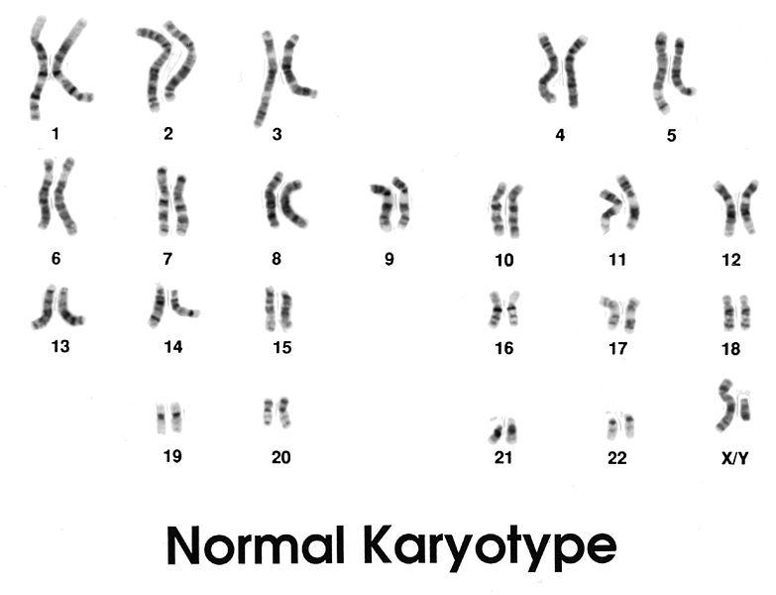

A
B
C

7. Why are females and males born in a roughly 50:50 ratio?
Half of all sperm produced at the end of meiosis carry an X chromosome and half carry a Y.

8. Cell biologists write females as _____46, XX_______ and males as _______46, XY________

9. Infer: Why is this process of making a karyotype useful for scientists? (what can it tell us?)
It helps to analyze homologous chromosomes and look for errors (that may have been caused by nondisjunction).

Lesson 14.2 Human Genetic Disorders Study Guide(Read ch.14.2; pgs. 404-407)
Key Question: What are the effects of errors in meiosis?

1. Reading Tool: Main idea (claim) and Details
As you read your textbook, identify the main ideas and details or evidence that support the main ideas/ claim. Use the textbook headings to organize the claims and details. Record your work in the table provided. Two examples are given for you.

Heading | Main Idea/ Claim | Details/ Evidence
Chromosomal Disorders | Nondisjunction, the failure of homologous chromosomes to separate during meiosis, can lead to chromosome number disorders | 2 copies of autosomes fail to separate. A person may end up with 3 copies of a chromsome = TRISOMY (down syndrome)  Only 1 sex chromosomes = monosomy (Turner’s syndrome)
From Molecule to Phenotype | A change in a single base of a gene can cause the gene to stop working or work improperly | A difference of one DNA base in a single gene determines whether a person has dry ear wax or wet earwax.
Disorders Caused by Individual Genes | Changes to individual genes affect specific protein associated with important cellular functions | Sickle-cell anemia: one of 2 hemoglobin proteins is defective  CF: deletion of three bases  Huntingtons: repeats CAG, which cause problems

Visual Reading Tool: Nondisjunction Use pages 404 & 405 to help answer the following
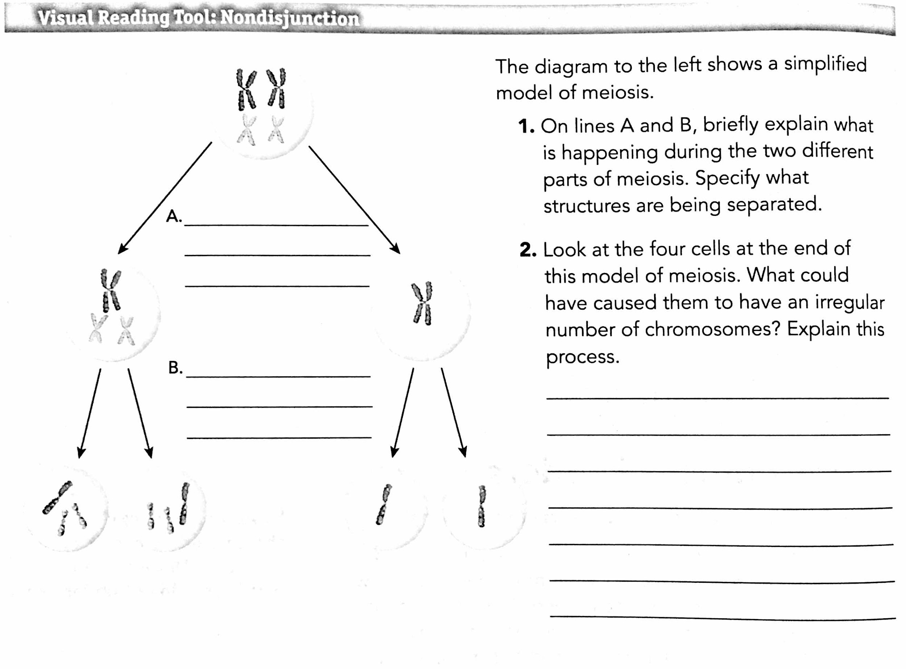

A
B
The diagram to the left shows a simplified model of meiosis.

2. For the areas; A and B, briefly explain what is happening during the two different parts of meiosis. Specify what structures are being separated!
A: homologous chromosomes separate and one of the pairs failed to do so.

B: Sister chromatids separate, but because of the mistake 2 gametes have too many chromosomes and 2 gametes do not have enough

3. Look at the 4 cells at the end of this model of meiosis. What could have caused them to have an irregular number of chromosomes? Explain this process.
Non-disjunction. When homologous chromosomes fail to separate during meiosis 1 (anaphase 1)

4. If one of the abnormal gametes is fertilized, a chromosomal disorder may occur. Reading pg. 404, describe the examples the text
provides using the table below:

Disorder Name | Chromosome Error  (where did the error occur?) | Effect of Disorder
Down Syndrome | Nondisjunction. There are 3 chromosomes at position 21 | Associated with a range of cognitive (thinking) disabilities and cerian birth defects
Turners Syndrome | Nondisjunction of an X chromosome (sex chromosome).  Only one X (no x or y with it) | Reproductive organs may not develop at puberty

5. Infer: Chromosome disorders can affect children that have 2 healthy parents. Support this claim with what you have just learned in this unit
Nondisjunction is an error in meiosis and not a genetic disorder found within a gene of one/ both of the parents.

